


Warm Hands for Wheelchair Users Program

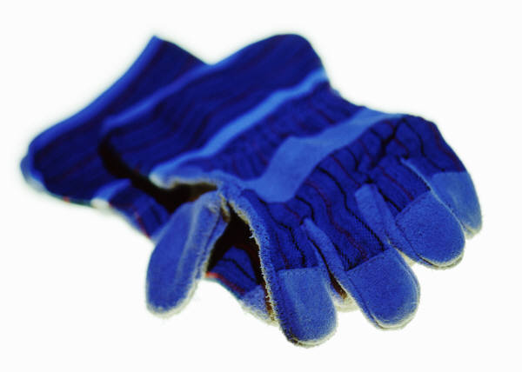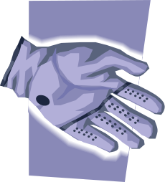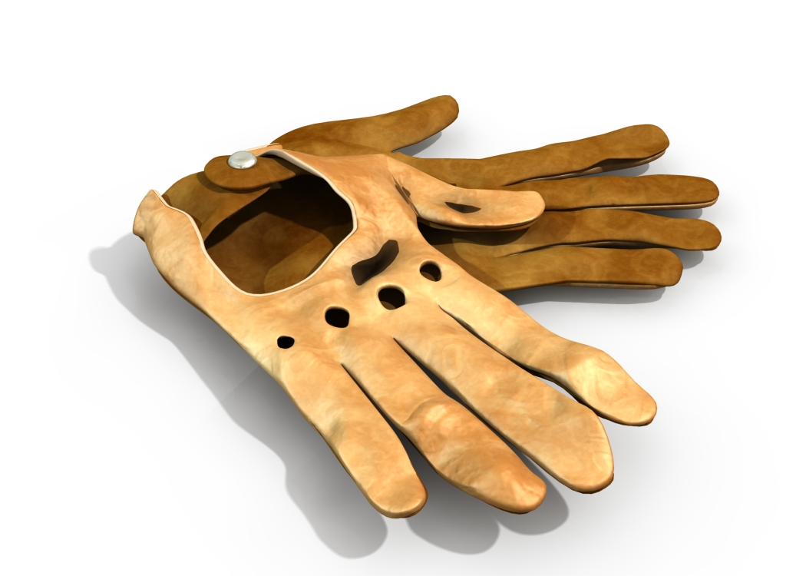

Do you use a wheelchair to get around?
Do your hands and fingers hurt from pushing?
Do your hands get cold and dirty from pushing?

Thanks to the generosity of the Employees Community Fund of Boeing California and their special grant, DRC is giving away free pushing gloves, to people using wheelchairs.

If you would like a free pair of pushing gloves come to DRC on Thursdays at 9:00am for group intake or call Richard Hernandez (562)427-1000 Ext.16
rhernandez@drcinc.org
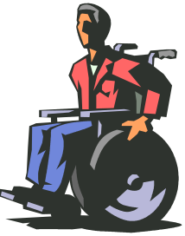

Disabled Resources Center, Inc.
2750 E. Spring St., Ste. # 100
Long Beach, CA 90806
www.drcinc.org

For reasonable accommodations please notify us a week in advance. To provide access for people with chemical sensitivity, please refrain from using scented products.

